Aliphatic Nucleophilic Substitution
I. A_{N}D_{N} (S_{N}2) http://chemistry.berkeley.edu/links/reactions.html
A. attack on opposite side of leaving group on saturated carbon
1. single step, concerted, second-order kinetics
2. frontier orbitals: σ* and n, optomizes overlap and minimizes repulsion
3. pentavalent TS (trigonal bipyramidal)
Methyl chloride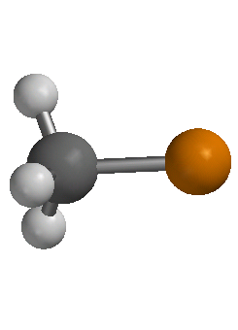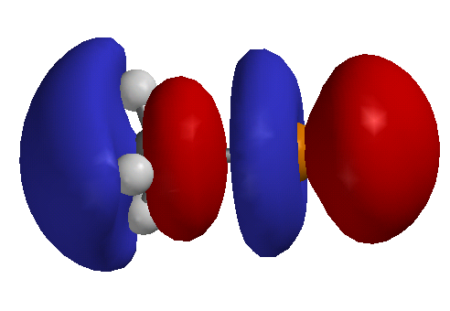
B. evidence for mechanism
1. rate is first-order in each component: rate = k[Nu][RX]
2. Walden inversion
3. unreactivity of substituted bridged complexes
II. D_{N} + A_{N} (S_{N}1)
A. first step is always assisted by solvation
1. ionization is on order of 150 kcal/mol
2. solvation can be 130 kcal/mol and larger
B. evidence
1. kinetics - first order ( beginning of reaction) changes to mixed order if [X⁻] and [Y⁻] are similar
2. solvolysis complicates, -d[RX]/dt d[RY]/dt
3. solvent and salt effect- ionization strength
4. rate independent of nucleophile
C. ion pairing
1. partial racemization in reactant
(a) recover ester after partial hydrolysis: exchange is faster than racemization so an intermediate prior to dissociated ion pairs
(b) azide stops racemization
III. theory of mixed S_{N}1 and S_{N}2
A. apparent S_{N}2 really is (ion pair type process) S_{N}1
B. both S_{N}1 and S_{N}2 occur
partial retention of configuration can occur by solvent reactions
IV. S_{RN}1, SET mechanism
T
D_{RN}
A_{RN}
T
See Chapter 12??, page
mechanism shows racemization
V. Neighboring Group Mechanism
A. kinetics of intramolecular nucleophilic displacement can be favored entropically
B. intramolecular leaving group often is easily displaced (second step) due to strain or positive charge
C. intermediate is necessarily a ring, 3-6 members are favored
D. common groups: Ph, COO-, COOR, COAr, OCOR, OR, OH, O-, NH₂, NHR, NR₂, NHCOR, SH, SR, S-, I > Br > Cl. See Chapter 3, phenyl displacement of brosylate
E. assistance of neighboring group is unnecessary for very good leaving groups, stable carbocations or nucleophiles
VI. Neighboring Group π-electron donors (V.D above were all lone pair donors except Ph)
A. X = tosylate and R = H, for acetolysis k_{trans-x} = 10¹¹ k_{cis-x}
B. X = p-O₂NC₆H₄CO₂, R = p-MeOC₆H₄, for hydrolysis in acetone/water k_{trans-x} k_{cis-x}
C. endo tricyclic octane
X = p-O₂NC₆H₄CO₂, R = H
kendo = 10¹⁴knorbornyl-X
VII. Neighboring Group σ bonds
A. norbornyl cation, non-classical
1. X = OSO₂C₆H₄Br, exo 350 times faster than endo, no endo product
2. ¹³C NMR at 5 K shows norbornyl cation has equivalent nuclei at 1 and 2 positions, barrier is < 0.2 cal/mol
B. cyclopropyl methyl cation (like allyl)
cyclopropylmethyl, cylobutyl and 3-butenyl compounds give the same products
C. methyl and H migration (hydride shift)– evidence of bridge intermediates equivocal
VIII. S_{N}i inversion/retention of configuration depends on solvent
IX. S_{N}1' (1/D_{N} + 3/A_{N}) and S_{N}2' (3/1/A_{N}D_{N})- alyllic leaving group
A. conjugate and direct substitution compete
B. rearrangement and internal returns occurs in polar solvents

C. isomers do not give same product distribution for S_{N}2' (example?)
XI. Reactivity
A. substrate structure: note steric, strain, electronic, neighboring group effects
B. nucleophile: charge, basicity, polarizability, steric effects, α-effect: NH₃ v H₂NNH₂
factors that determine site of attack by ambident nucleophiles
a. hard/soft base attack hard/soft acid (carbocation/tetrahedral carbon)
b. coordinating metals promote carbocation formation (hard acid)
c. protic solvents solvate harder base so softer base is better nucleophiles
example: thiols and alcohols in water and dioxane
d. steric effects
C. good leaving group: weak base, strain
D. different media effects on reactants and TS: solvation, counter (metal) ion, salt effects, common ion effects
E. phase-transfer catalysis in immicible solvents
1. anion becomes soluble in organic solvent using soluble cation or chelating agent
2. ammonium and phosphonium salts
3.heterocycles and cryptands chelate metal ions which attract anions
Superacid media
I. superacids used to observe carbocations by NMR or other methods
a. SO₂ and SO₂ClF are solvents plus FSO₃H-SbF₅ or HF-SbF₅
b. RF + SbF₅ R+ + SbF₆-
c. ROH + SO₂ R+ + HSO₃⁻
d. RH + FSO₃H + SbF₅ R+ + SbF₅FSO₃- + H₂
II. primary carbocation is never detected in solution, only secondary and tertiary
III. simple hydrocarbons form t-butyl cation in superacid media
a. methane, ethane, propane, t-hexyl, pentyl
b. proton exchange may be concerted or stepwise
c. protonation of CH bond -detect CH₅⁺ in gas phase
see Sommer & Bukala Acc. Chem. Res 1993, 26, 370
IV. conjugated carbocations have been observed solution
a. cyclopropylmethyls are more stable than benzyl, p orbital parallel to C3-C4 bond (see VIIb)
b. α-heteroatom with lone pair
c. acylium ions
stability/reactivity of carbocations
1. pK_{R+} for
2. D(R⁺-H⁻) (see March page 171)
3. ¹³C chemical shifts correlate with electron density. (March:Table 5.2 page 173)
generation/fate of carbocations
1. dissociation of leaving group (reverse)
2. electrophile addition to double bond (reverse)
3. carbocation rearrangements
Selected Mechanisms
I. alkyl halide and organometallic reagents
A. S_{N}2 in many cases, sometimes SN1 and SET/radical
B. RX + R'M [RX-• R'• M+] R• + X- +R'• + M+ RR' + X- + M+]
(T +D_{N} + A_{R})
II. Reactions of sulfonic acid derivatives with nucleophiles

