Nucleophilic Substitution at a saturated carbon
http://chemistry.berkeley.edu/links/reactions.html
- Nucleophilic substitution
  - Base hydrolysis- hydroxide substitution of alkyl halides prototypical reaction
  - Mechanism follows two extreme kinetic laws
    - 2nd order: first-order in each component: rate = k[Nu][RX]
    - 1st order: independent on nucleophile rate = k[RX]
    - some reaction are mixed: rate = k₁[Nu][RX] + k₂[RX], plot?
- bimolecular mechanism: d[product]/dt = k[Nu][RX]
  - RDS – rate determining step includes hydroxide and and alkyl halide
  - . single step, concerted
  - Concerted – energy of bond with hydroxyl used to break one with halide
  - Activation entropy is unfavorable -17 J mol⁻¹ K⁻¹ ~ 4 kcal mol⁻¹ K⁻¹
  - How many electrons around carbon in transition state
  - Transition state – linear: O-C-Br – optimum overlap
    - Methyl bromide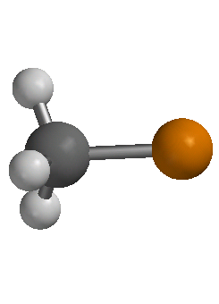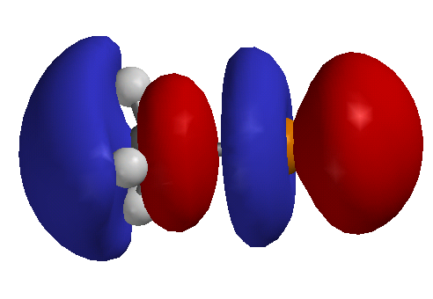
    - σ* is lowest unoccupied orbital – linear, accepts OH lone pair
    - Charge distributed over O and Br
    - pentavalent TS (trigonal bipyramidal)
    - S_{N}2, Substitution Nucleophilic Bimolecular
- Unimolecular mechanism
  - Tertiary halide d[product]/dt = k[RX]
  - Nucleophile cannot be involved in rate determining step, hybridization of cation
  - Rate is independent of hydroxide, reacts after RDS
  - Omnipresent water competes, cannot be distinguished- same kinetics
  - Energy of C-Cl dissociation obtained from collision, solvation of ions and entropy of activation: 51 J mol⁻¹ K⁻¹, (~12 cal mol⁻¹ K⁻¹)
  - tButyl group relaxes to planar geometry
    - releaves steric interactions
    - sp³ to sp² : stronger bonds!!
    - Remaining orbital sp³ to p, increase in energy!! Inhibit reaction?
  - Substitution Nucleophilic Unimolecular: S_{N}1
- Solvent effects
  - Solvolysis of tBuCl in 50% H₂O/50% ethanol 3x10⁴ faster than in ethanol
    - Transition state for S_{N}1 has large charge development
    - More polar solvents will stabilize charges in transition relative to ground state
    - Solvation of nucleophile makes it less reactive: does not participate in RDS
  - Charge separation for S_{N}2 less in transition state
  - Ions less stable, more reactive in less-polar solvent
  - Polar solvent is require to dissolve ions though
  - Polar prortic to polar aprotic, azide substitution 4x10⁴ faster in DMF then MeOH
  - Some S_{N}2 reaction increase 10⁹, dimethylsulfoxide/methanol
- Structure effects
  - S_{N}2 slower as substitution increase: steric effects
    - inhibition of nucleophile
    - Crowding of transition state, pentacoordinate
  - S_{N}1faster as substitution increases
    - Steric effects relieved in nearly tricordinate transition state
    - Electron donating alkyl groups disperse charge
    - Hyperconjugation
      - supported by 10% increase in k_{H}/k_{D} per deuterium
      - secondary isotope effect – CH bond is not broken in TS
  - Methyl and ethyl derivative are always S_{N}2 in solution, methyl and ethyl cations are too unstable. SN1??
  - tertiary derivatives are almost always S_{N}1
    - too much steric inhibition for S_{N}2
  - secondary derivatives – often have mixed kinetics: d[P]/dt = k₁[Nu][RX] + k₂[RX]
  - What about benzyl and allyl halides?
  - Vinyl halide? Where does a nucleophile attack (LUMO)
  - Concerted S_{N}2 never observed for vinyl or aryl halide
  - S_{N}1 rare for vinyl or aryl halide, why?
  - Bridging
    - strain to make planar cation
    - How could you demonstrate rates were not for S_{N}2?
  - Cyclopropyl methylgroup unusual primary cation
    - Bent bond delocalize with cation?
- stereochemistry
  - S_{N}2 results in inversion of configuration
    - Displacement of idodide by radioactive iodide k_{sub} = (3.00+0.25)x10⁻⁵ (30 ⁰C)
    - Note half inversion results in complete racemization
    - k_{inv} = ½ k_{rac} = (2.88+0.03)x10⁻⁵ (30 ⁰C) – k_{sub} = k_{inv}
  - simple S_{N}1 results in racemization of configuration, not inversion
    - Ion paring protects one side of cation
    - Rarely is complete racemization realized
    - Longer lived cations racemize more
- S_{N}i retention of configuration (no racemization)- double inversion?
  - Rate = k[ROH][SOCl₂]
  - ROSOCl isolated from reaction: intermediate

  - Inversion occurs in presence of pyridine, choride addition is faster than thionyl ester decomposition
- Neighboring group effects
  - kinetics of intramolecular nucleophilic displacement can be favored entropically
  - .intramolecular leaving group facile due to strain or positive charge
  - Evidence of the participation of sulfonium ion mechanism? rule out simple inductive effect. Hint: symmetry of intermediate.
  - intermediate is necessarily a ring, 3-6 members are favored
  - common groups: Ph, COO-, COOR, COAr, OCOR, OR, OH, O-, NH₂, NHR, NR₂, NHCOR, SH, SR, S-, I > Br > Cl.
  - assistance of neighboring group is unnecessary for very good leaving groups, stable carbocations or nucleophiles
  - Stereochemistry (always?) is important
- Effect of nucleophile structure
  - S_{N}1, rate is independent of nucleophile structure because addition is after RDS
  - S_{N}2, better base (thermodynamic) makes better nucleophile (kinetic) is a general trend
    - Works well for same atom: EtO⁻ > PhO⁻ > MeCO₂⁻ > NO₃⁻
    - Not for atoms of very different polarizability: RS⁻ > RO⁻
  - Good nucleophile will favor S_{N}2 v. S_{N}1. i.e. OH⁻ v. H₂O. carbon cation doesn’t care
- Effect of leaving group
  - Weak bases are good leaving groups examples?
  - Some good leaving groups are good nucleophiles as well
    - I- is a nucleophilic catalyst
    - Adds and is later displaced

