Exam 19th, CH8 9th CH 9 12th, CH10 21th
- Carbanion Formation
  - reduction of halides
    - Grignard, Lithium reagents, pka conjugate acid?
    - what is the LUMO of methyl bromide (4.78 ev) or ethane (7.6 ev)
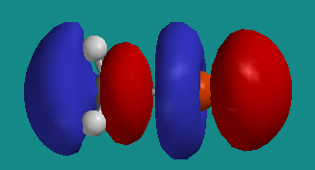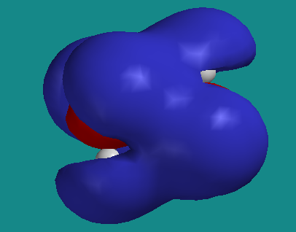
    - Mechanism for Gignard formation: Eur. J. Org. Chem. 2008, 6043-6049, F. Bickelhaupt, M. Newcomb, C. B. DeZutter, H. J. R. de Boer*The Grignard Reagent Formation Reaction of 2-Chloro-1,1,1-triphenylethane Re-visited”: What are missing species/steps?
  - carbanion without delocalization are nominally sp³, pyramidal
  - enolate and other stabilized anions
    - use a strong base: NaNH₂, BuLi, LDA (lithium diisopropyl amide) pKa’s of conjugate acids? Compare NaOH, why LDA? Stoichiometric!!
must recognize delocalization, NO bond lengths?
  - geometry restrictions on π delocalized anions
    - sp² orbitals on carbon, p orbital co planar with π orbital
    - estimate pKa of 1,3-cyclohexandione?
    - double bond and 4 attached atoms must be coplanar
    - estimate pKa of 1,3-bicyclo[2.2.2]octandione (What is most acidic CH?)
  - enols form reversibly in presence of acid or base catalyst, pka
    - enol is isomer of ketone - tautomers – readily interconvertible isomers
    - tautomerization is normally two step intermolecular process
    - enol and carbanion in general can be used to label ketone with deuterium
    - β-dicarbonyls have significant enol content fix dash
    - hydrogen bonding and additional delocalization
    - solvent is important, 92% enol in hexane, 15% in water, why?
  - don’t forget reactant state
    - anti conformation has favorable dipole-dipole interaction
    - lowers energy relative to pentadione
  - proton loss is slow even for stronger carbon acids
- Carboxylation
  - organometallic with electropositive metal (Na, Li, Mg) form strong base.
- Elimination reactions (are possible)
  - stabilized anion intermediate, pka?
- decarboxylation can form carbanion intermediate, pKa?
- alkylation of carbanions
  - must avoid elimination as in 3.1, since many carbanions are strong bases
  - weak base, pka?
  - use electrophiles that can’t or don’t easily eliminate and base with low steric hindrance
    - allyl chloride does not have acidic hydrogen β to Cl (avoids allene formation)
    - acetylide is not bulky, but is a very strong base, pka?
- Reimer-Tiemann
  - Phenol is an enol of 2,4-cyclohexandienone
  - enolate is good nucleophile, full mechanism and delocalized electrons as an exercise
  - dichlorocarbene: a good electrophile, empty p orbital
  - some para product forms
  - Kolbe reaction yields nearly exclusive ortho with sodium counter ion
    - para substitution is more important for potassium, why?
- Darzens reaction
- Favorski reaction
- Base-Catalyzed Halogenation of Ketones (figure)
  - rate = k_{obs}[ketone][base]
    - independent of [Br₂], what does this mean?
  - isotopic labeling
    - typically rate of exchange with deuterium is the same as racemization
      - then deuteration occurs equally from both sides
      - anion symmetrization must be faster than deuteration
  - A deuterium isotope effect is observed
  - indicates deprotonation is RDS
  - back to halogenation
    - replacement of subsequent hydrogens by bromine is faster
    - electron withdrawing Br stabilizes anion
  - methyl ketones form bromoform (haloform reaction)
    - Why doesn’t OH leave instead of CBr₃? Experimental test for OH leaving?
- Acid catalyzed halogenation, equilibrium at beginning is two steps (see above)
  - enol is formed, reacts with halogen
  - enol of product less reactive than reactant, bromo enol is poor π donor, why?
  - Stop at mono-halogenation
  - rate is same for iodination, what is RDS?
  - what removes proton from cation intermediate? What is the solvent?

