- understanding reactivity is imperative in predicting products and optimizing yield and elimination waste
  - example of useful synthetic reactions (. Chem. Eur. J. 2009, 15, 6790)
  - Knowing a molecule’s reactivity (possible reactions) answers the following questions:
    - What possible side products are formed?
    - What are the optimum conditions?
    - Best reagents? What do the reagents do?
    - What determined which carbonyl was attacked?
    - What determines stereochemistry?
- What is a reaction?
  - transformation of one or more compounds into new compounds
  - requires the breaking and/or making of bonds
  - bonds: mutual attraction of two or more nuclei for electrons
  - Reactions involve movement of electrons and nuclei.
- Chemistry is about electrons: Understand electrons understand reactivity
  - electron position determines structure
    - nuclei follow the electrons
    - orbital occupation
  - electron position/movement determined by orbital properties
    - energy, size, symmetry (node: surface where Ψ and Ψ² = 0)
- Why do reactions occur? = Why do electrons move?
  - predict products based on reagent structure (electron orbital occupation)
    - Understand structure
    - correlate structure with reactivity
    - for example, carbonyl groups! σ, π, σ*, π*, lone pairs, polarized bond
- electronic structure principles
  - only valence electrons move during reaction (why?)
  - bonds (MO category) are based on atomic orbitals
    - s, p, d, f (how do they differ?) nodes: radial and angular
  - electronic structure of carbon?
    - Pauli Exclusion Principle, Hund’s rule
    - What are the requirements to make a bond between two atoms?
    - H and Ne? H and F? H and HF? H₂O and HF?
  - orbital contraction?
    - effective nuclear charge: O 2s smaller than C 2s, Traylor 1-16
    - Energy difference? Diagram
  - bond formation – atomic orbital mixing
- Molecular Orbitals: MO theory
  - bonds are MO’s: orbital overlap of similar symmetry and energy along bonding axis
  - nodes occur were sign change: wavefunction = 0
    - bound systems have wave properties Traylor 1-9, 1-10, https://www.google.com/search?q=guitar+string+wavelength+images&espv=2&biw=1122&bih=636&tbm=isch&tbo=u&source=univ&sa=X&ved=0CDQQ7AlqFQoTCPy6mvPqxscCFY-Lkgod-FwO3A
http://www.cameronmizell.com/blog/guitar-tone-from-the-fingers/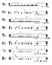
http://cnx.org/contents/031da8d3-b525-429c-80cf-6c8ed997733a@7.55:126/Superposition-and-Interference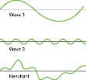
wave functions are macroscopic and atomic level phenomena: boundaries lead to quantization of states: Nodes, phases, superposition of states
electrons and strings have any frequency until boundaries are established
    - details of s orbital
https://www.google.com/search?q=2s+orbital+node&espv=2&biw=1122&bih=636&tbm=isch&tbo=u&source=univ&sa=X&ved=0CCkQsARqFQoTCO-DwPqPyccCFYUGkgod0GsAHg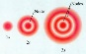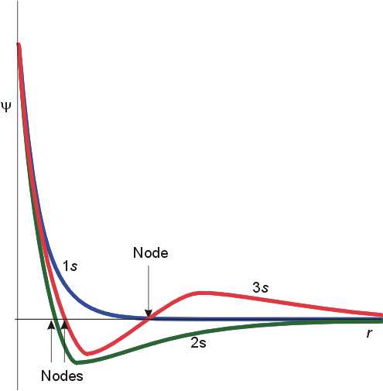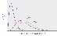
    - details of p orbital https://www.google.com/search?q=2p+orbital+nodes&espv=2&biw=1122&bih=636&tbm=isch&tbo=u&source=univ&sa=X&ved=0CDcQsARqFQoTCKKiwZyTyccCFYEQkgodBU8HyQ
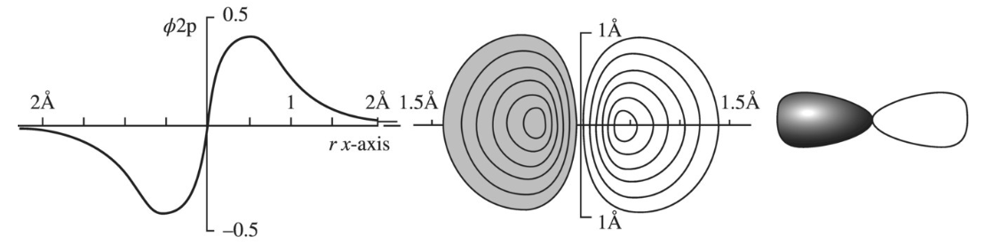
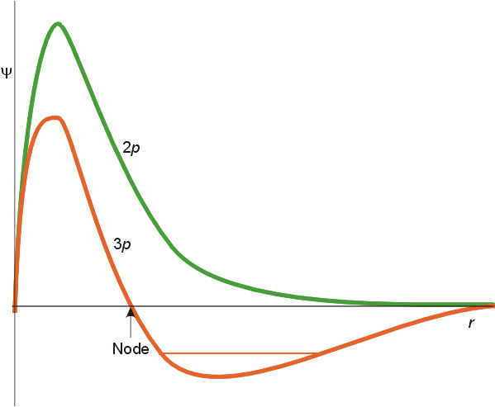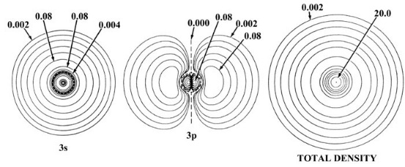
Number of nodes increase +1 for higher levels (harmonics) (3s and 3p and 3d all have two nodes (radial plus angular).
    - “construction” of σ and π orbitals1
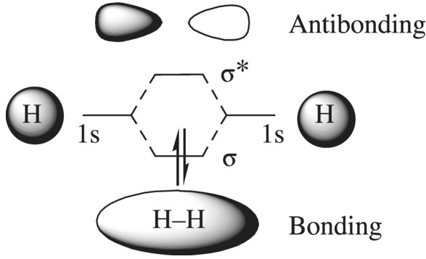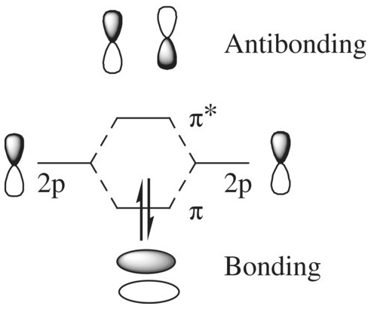
    - Extent of overlap depends on position and orbital symmetry:
  - s and p_{x} does not work
    - ++, +- overlap regions equally unlike s and p_{z}
    - s has axial symmetry along bonding axis, p_{x} has mirror plane
    - no net overlap, non-bonding interaction
  - Conservation of orbitals
    - #AO’s in = #MO’s out
    - two ways to mix two s orbitals, shading indicates opposite sign
    - antibonding orbitals have new node (change in color) across bonding axis
    - no electron density at node
    - electron density between nuclei hold nuclei together (bonding)
    - electron density outside pulls apart (antibonding orbital) (what happens when H₂ or RBr reduced (add electron) show energy diagrams)
  - electron energies correlate with orbital occupation
    - bonding < AO, (non-bonding) < antibonding
    - energy diagram of 2 π electrons versus two p electrons
    - MO correlates with AO: C-O < C-C. Why? Diagram?
  - Huckel MO’s for polyenes (contiguous p orbital/ planar) http://chemistry.umeche.maine.edu/CHY252/Pi-orbs.html
    - Huckel low level calculation, easy to determine
    - #MOs = #AOs (only adjacent AOs interact)
    - MO’s have alternate σ plane and C2 symmetry
    - # nodes = 0, 1, 2, 3 etc from lowest to highest orbital: odd nodes means ends have opposite signs
    - #bonding = #antibonding, related with respect to energy, bonding interaction, density (coefficient)
    - Which are bonding and antibonding? Compare with p AO or overlap
    - calculate energies: ethene, allyl, butadiene, pentadienyl
http://www.chem.ucalgary.ca/SHMO/
    - butadiene Ψ₁ < Ψ₁ ethene < butadiene Ψ₂
    - allyl http://csi.chemie.tu-darmstadt.de/ak/immel/tutorials/orbitals/molecular/allyl.html
    - butadiene: http://csi.chemie.tu-darmstadt.de/ak/immel/tutorials/orbitals/molecular/butadiene.html
  - Orbital population
    - Sum of squares of all coefficients for an atom = 1
    - Bond order is sum of product of coefficients on adjacent atoms for each electron
    - Rotation in butadiene for 2 and 4 electrons
    - calculate the energy required to break the C2-C3 π bonding of butatdiene.
                - 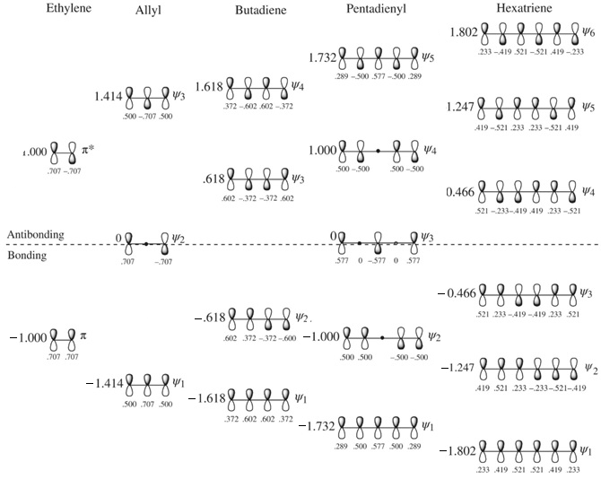
                - 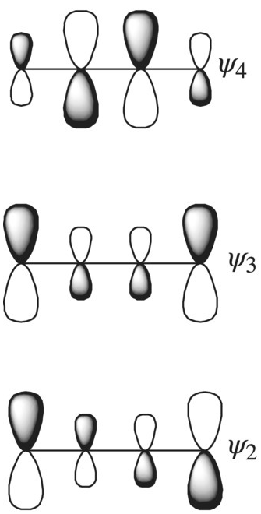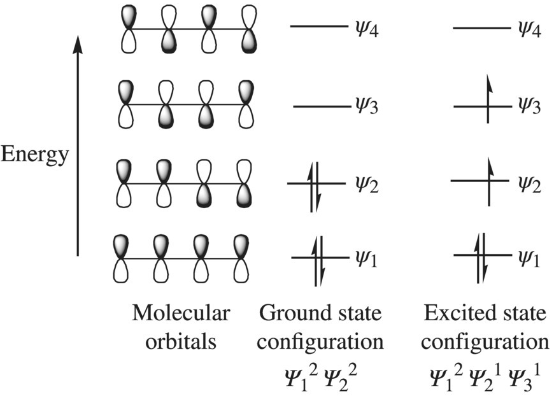

- Huckel MO’s for cyclic polyenes.
  - Evidence for delocalization for benzene? Structure, spectral, chemistry, energetic?
  - inscribe regular polygon in circle of 2β radius: (Frost diagrams)
  - every vertex is a an orbital energy, one vertex at circle bottom, radius is 2β
  - β is energy of electron in ethene π orbital
  - analytical geometry for calculation of energies: cyclopropyl example
  - horizontal diameter is 0 bonding energy, same as AO
  - 4 member ring
    - 2 electrons in lowest MO, two in each degenerate MO
    - unpaired (radicals) non-bonding
    - total energy is 4β relative to AO (p orbital)
  - 5 member ring
    - anion has 6 electrons
    - all paired in bonding orbitals
    - follows 4n+2 rule
    - explains acidity of cyclopentadiene
- Delocalization, resonance, conjugation (electrons not nuclei move!)
  - more effective in π systems than σ (enone is butadiene equivalent!, missing poor resonance form) carboxylate is equivalent to which all carbon system how many electrons in each π system?
  - p orbitals must be collinear (no twisting), structures with charge separation are not as important
- hybridization
  - mixing of AO’s from same atom instead of different atoms
  - process same as forming MO’s
  - hybridization orbital energy correlates with AO energy
    - p > sp³ > sp² > sp > s, what do exponents mean?
  - number of un-hybridized p orbitals often determines hybridization
    - one p orbital used for π double bond, two p are left to make sp² orbitals (3 x 2/3?)
    - What is hybridization of ethyne carbons, allene?
  - hybridization improves overlap – Taylor graphs 3-9
    - sp³ CC bond length is 1.5 A (1.3 A for sp²)
    - sp^{x} orbitals “point” electrons better
    - relative overlap power: s (1.00), p (1.72), sp (1.93), sp² (1.99), sp³ (2.00)
  - methane versus dichloromethane – not sp³?
  - Cyclopropane hybridization
    - Cyclopropane BDE (kcal/mol): propane = 95 (2º) cyclopropane = 106, ethene = 110, acetylene 127 (Substituent Effects in Radical Chemistry ed, Heinz G. Viehe, Zdenek Janousek, Robert Merény) and J. Segall, R. Lavi, Y. Wen, and C. Wittig J. Phys. Chem. 1989, 93, 7287-7289.
    - Cyclopropyl radical has 5 kcal/mol inversion barrier, not planar
    - ¹J_{HC} has linear dependence on s character
      - ¹J_{HC} = 125 (sp³), 160 (sp²), 240 (sp) Hz
      - Scalar coupling between nuclei depends on electron density on nucleus
      - CH coupling constant: cyclopropane (165.4 Hz) Annual Review of N.M.R. Spectroscopy By Eric Francis Mooney

- Hyperconjugation – experimental observations
  - increasing alkyl substitution reduces heat of alkene hydrogenation:
2-trans-hexene (27.3 kcal/mol)/1-hexene (29.7 kcal/mol) – same product!! http://classes.yale.edu/chem220/STUDYAIDS/thermo/HfAlkenes.html
  - alkyl substitution makes cation formation faster
  - alkyl affect attributed to hyperconjugation
  - Hyperconjugation: π delocalization of σ electrons
  - sometimes described as bond-no bond resonance
  - side on delocalization – precursor to hydride rearrangement
- factors that affect bond strength, length, rotation
  - CH (101 kcal/mol) C-C (83 kcal/mol) C=C (143 kcal/mol) OH (110 kcal/mol) C-O (86 kcal/mol C=O (179 kcal/mol)
    - Ketone v. enol?
  - Electronegativity (why?), overlap, hybridization (why?)
  - Simple alkanes – staggered and eclipsed conformations
    - – ethane – 2.7 kcal/mol barrier – 10¹² s at room temperature
  - Examples of restricted rotation
  - Aliphatic rings in general
- review - atomic/molecular properties
  - electronegativity
    - inductive through bond
    - field effect is through space (cis and trans 1,2-disubstituted cyclopropane).
    - charge/charge > charge/dipole > dipole/dipole
  - size – orbital overlap – mismatch in size, HF (565 KJ/mol) v HI (295 KJ/mol)
  - delocalization
  - steric effects – inhibit approach of atoms for favorable overlap
    - Triethyl amine versus quinuclidine
loss of chloride inhibited by steric effect
- Types of reagents
  - Lewis acids and electrophiles: empty (or potential empty) orbital, electron deficient
    - cations: H⁺, PhCH₂⁺, NO₂⁺, Na⁺
    - neutrals: AlCl₃, SO₂, CH₃Br, Cl₂, FeCl₃, CH₃CHO, ROH (leaving groups and empty orbitals, carbonyls in general)
    - low energy orbitals available to accept electrons
  - Lewis bases and nucleophiles: lone pairs, π and σ electrons, electron donors
    - anions: AlH₄⁻, HO⁻, CN⁻, RMgBr, RS⁻, Cl⁻
    - neutral: RNH₂, RHC=CH₂, ROH, R₃Si-H, R₃C-H
    - high energy orbitals for donation
  - radicals – unpaired electrons
  - propose a mechanism
  - opposite charges attract
  - chlorine has partial negative charge why doesn’t it attach cations?
- Types of reactions
  - Addition
  - Elimination
  - Substitution
  - Rearrangement
  - Limited number of fundamental steps
  - Bromine addition to alkene – does not appear to have polarized reagents
- Stereochemistry
  - R,S
  - Cis/trans, E/Z (2-butene, 2-chloro,2-butene, 2,3 dichlorobutene)
  - Cis and trans 1,X-dimethylcyclohexane

INTERMEDIATE ORGANIC CHEMISTRY, 3rd Ed. ANN M. FABIRKIEWICZ, JOHN C. STOWELL, Wiley, ISBN 978-1-118-66220-5

